Project Design Phase-II

Technology Stack (Architecture & Stack)

|  |  |
| --- | --- |
| Date | 16 October 2022 |
| Team ID | PNT2022TMID12805 |
| Project Name | Personal Assistance For Seniors Who Are Self-Reliant |



Medicine / Supplements



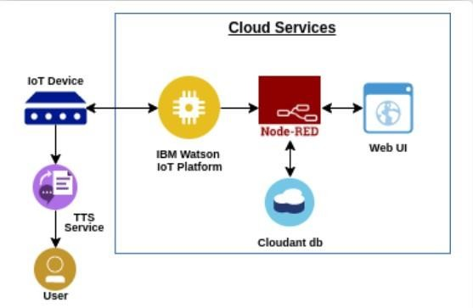



Elders



Table-1 : Components & Technologies:

|  |  |  |  |
| --- | --- | --- | --- |
| **S.**  **No** | **Component** | **Description** | **Technology** |
| 1. | User Interface | Mobile App | MIT |
| 2. | Application Logic-1 | Gathering information about medications and examining timing | Python |
| 3. | Application Logic-2 | Alarms | IBM Watson |
| 4. | Cloud Database | Cloud database service | Cloudant DB by IBM |

Table-2: Application Characteristics:

|  |  |  |  |
| --- | --- | --- | --- |
| **S.**  **No** | **Characteristics** | **Description** | **Technology** |
| 1. | Open-Source Frameworks | Creating mobile applications, setting up IoT devices, programming IoT devices, using a text-to-speech service, and storing data in the cloud | BM Watson, Node Red, IBM Cloud, and Mit |
| 2. | Security Implementations | Putting encryption to use for security | SHA-256. |
| 3. | Scalable Architecture | The application can load as many members as there are logged in | IBM Watson, Mit |
| 4. | Availability | Application is offered 24/7 | IBM Watson, Node Red, IBM Cloud, and Mit |
| 5. | Performance | Reminder with correct timing | Iotf, Ibm, and Watson |